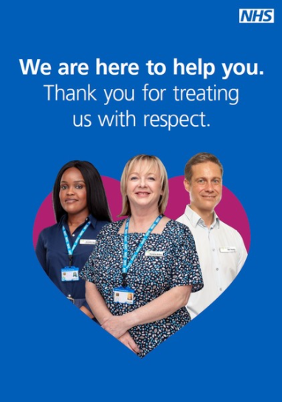
We are looking for a range of NHS staff who are happy to feature in campaign materials and available to be photographed at the end of March.
Photography will seek to widen the NHS staff featured in ‘staff respect’ assets to include more roles in primary and secondary care.
We are also keen to hear from primary care staff working in a multidisciplinary team.
The photography could also be used across other NHS campaigns including ‘Help Us, Help You’.
For illustrative purposes only.

We are interested in hearing from NHS staff, of all ages and backgrounds – no previous modelling/acting experience necessary but you will need to be available in London for a couple of hours (between 8am and 5pm) on one of the following days: 29, 30 or 31 March 2022.
Travel expenses will be covered.
We are particularly interested in hearing from you if you are working in primary or secondary care in the following roles:
Primary and Secondary Care roles | Primary Care Multidisciplinary Team Roles
Optometrist
 | Dietitian
Pharmacy Technician | Podiatrist
Pharmacy Counter Staff | Occupational Therapist
Dentist Receptionist
Dental Nurse | Paramedic
Dentist | Social Prescribing Link Worker
 | Care Coordinator
NHS 111/999 Call Handler | Health and Wellbeing Coach
Hospital Reception Staff
Hospital Nurse | Nursing Associate
Hospital Doctor/Consultant
Hospital Porter
Paramedic

If you are interested in featuring in the campaign, please complete the form on the next page and send a headshot photograph to nhs@23red.com by 12pm on Monday 14 March 2022. Thank you.

Full name:

Contact phone number:

Contact email address:

Job title/role:

Job band/grade:

Professional registration number:

Where do you currently work?

_________________________________________________________________________________Where do you live (Town/City)?

How long have you been employed in the NHS?

Are you happy to appear in a national communication campaign representing the NHS?

Please select which day is best for you to attend a photoshoot in London?
Tuesday 29 March YES / NO
Wednesday 30 March YES / NO
Thursday 31 March YES / NO
You’ll be asked to attend for 2 hours, sometime between 8am-5pm. We can try and make this work around your schedule.

Continued over the page…
__________________________________________________________________________________Have you appeared in any other advertising campaigns (print, TV, online, unpaid etc.) for the NHS or other?

Do you wear a uniform? If no, please specify what you wear for work. If yes, please detail what uniform you wear.

Do you have a criminal record?

How did you hear about this?

__________________________________________________________________________________
Please remember to attach a head shot photograph when submitting your completed form to nhs@23red.com.
Thank you.

